**Module 1_ AWS_Fundamentals_Cloud**

==================================================================================

Submitted to Vikul_Sir

Submitted by Nalathati Rahul

Submission Date – 03/Feb/2026

==================================================================================

L5 - Install Tomcat web application server in AWS EC2 Ubuntu Instance and access Tomcat using a web browser

Step: 1 login into AWS console and an ec2 instances

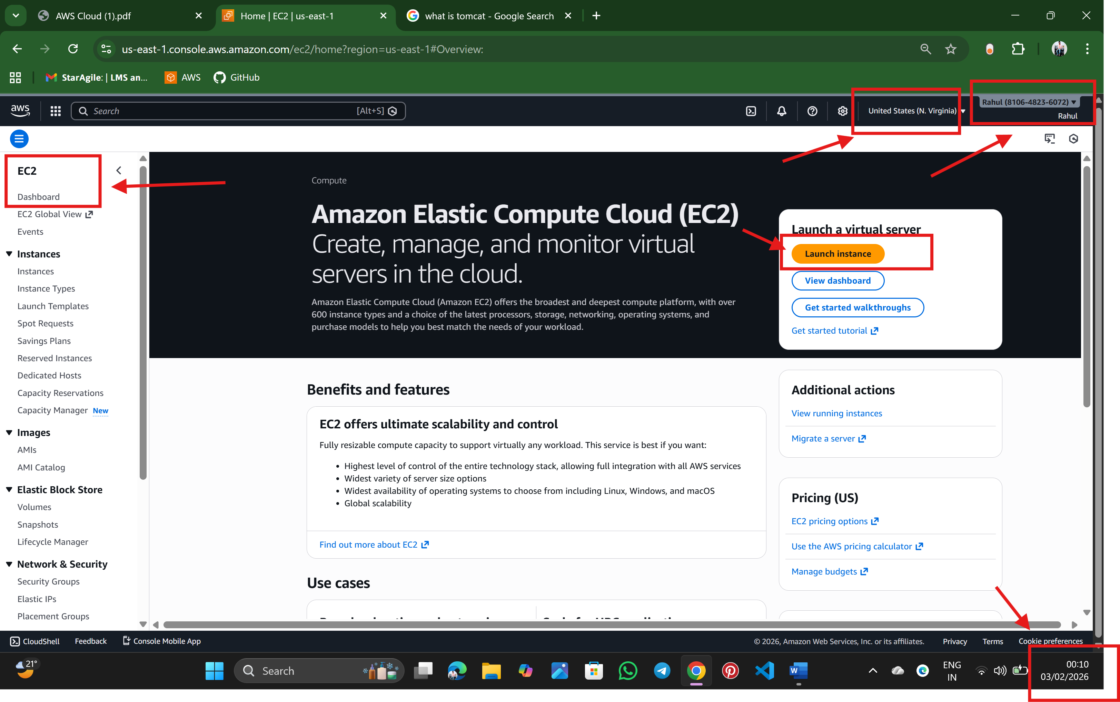

Step:2 Search ec2 instances

🡪name the instance: Tomcat-web-server

🡪Select the OS (AMI): Amazon Linux

🡪Select the instance type: t3. micro

🡪create a key pair

🡪check the network configure🡪 SSH 22port and TCP 8080 port add inbound rules

🡪click launch instance

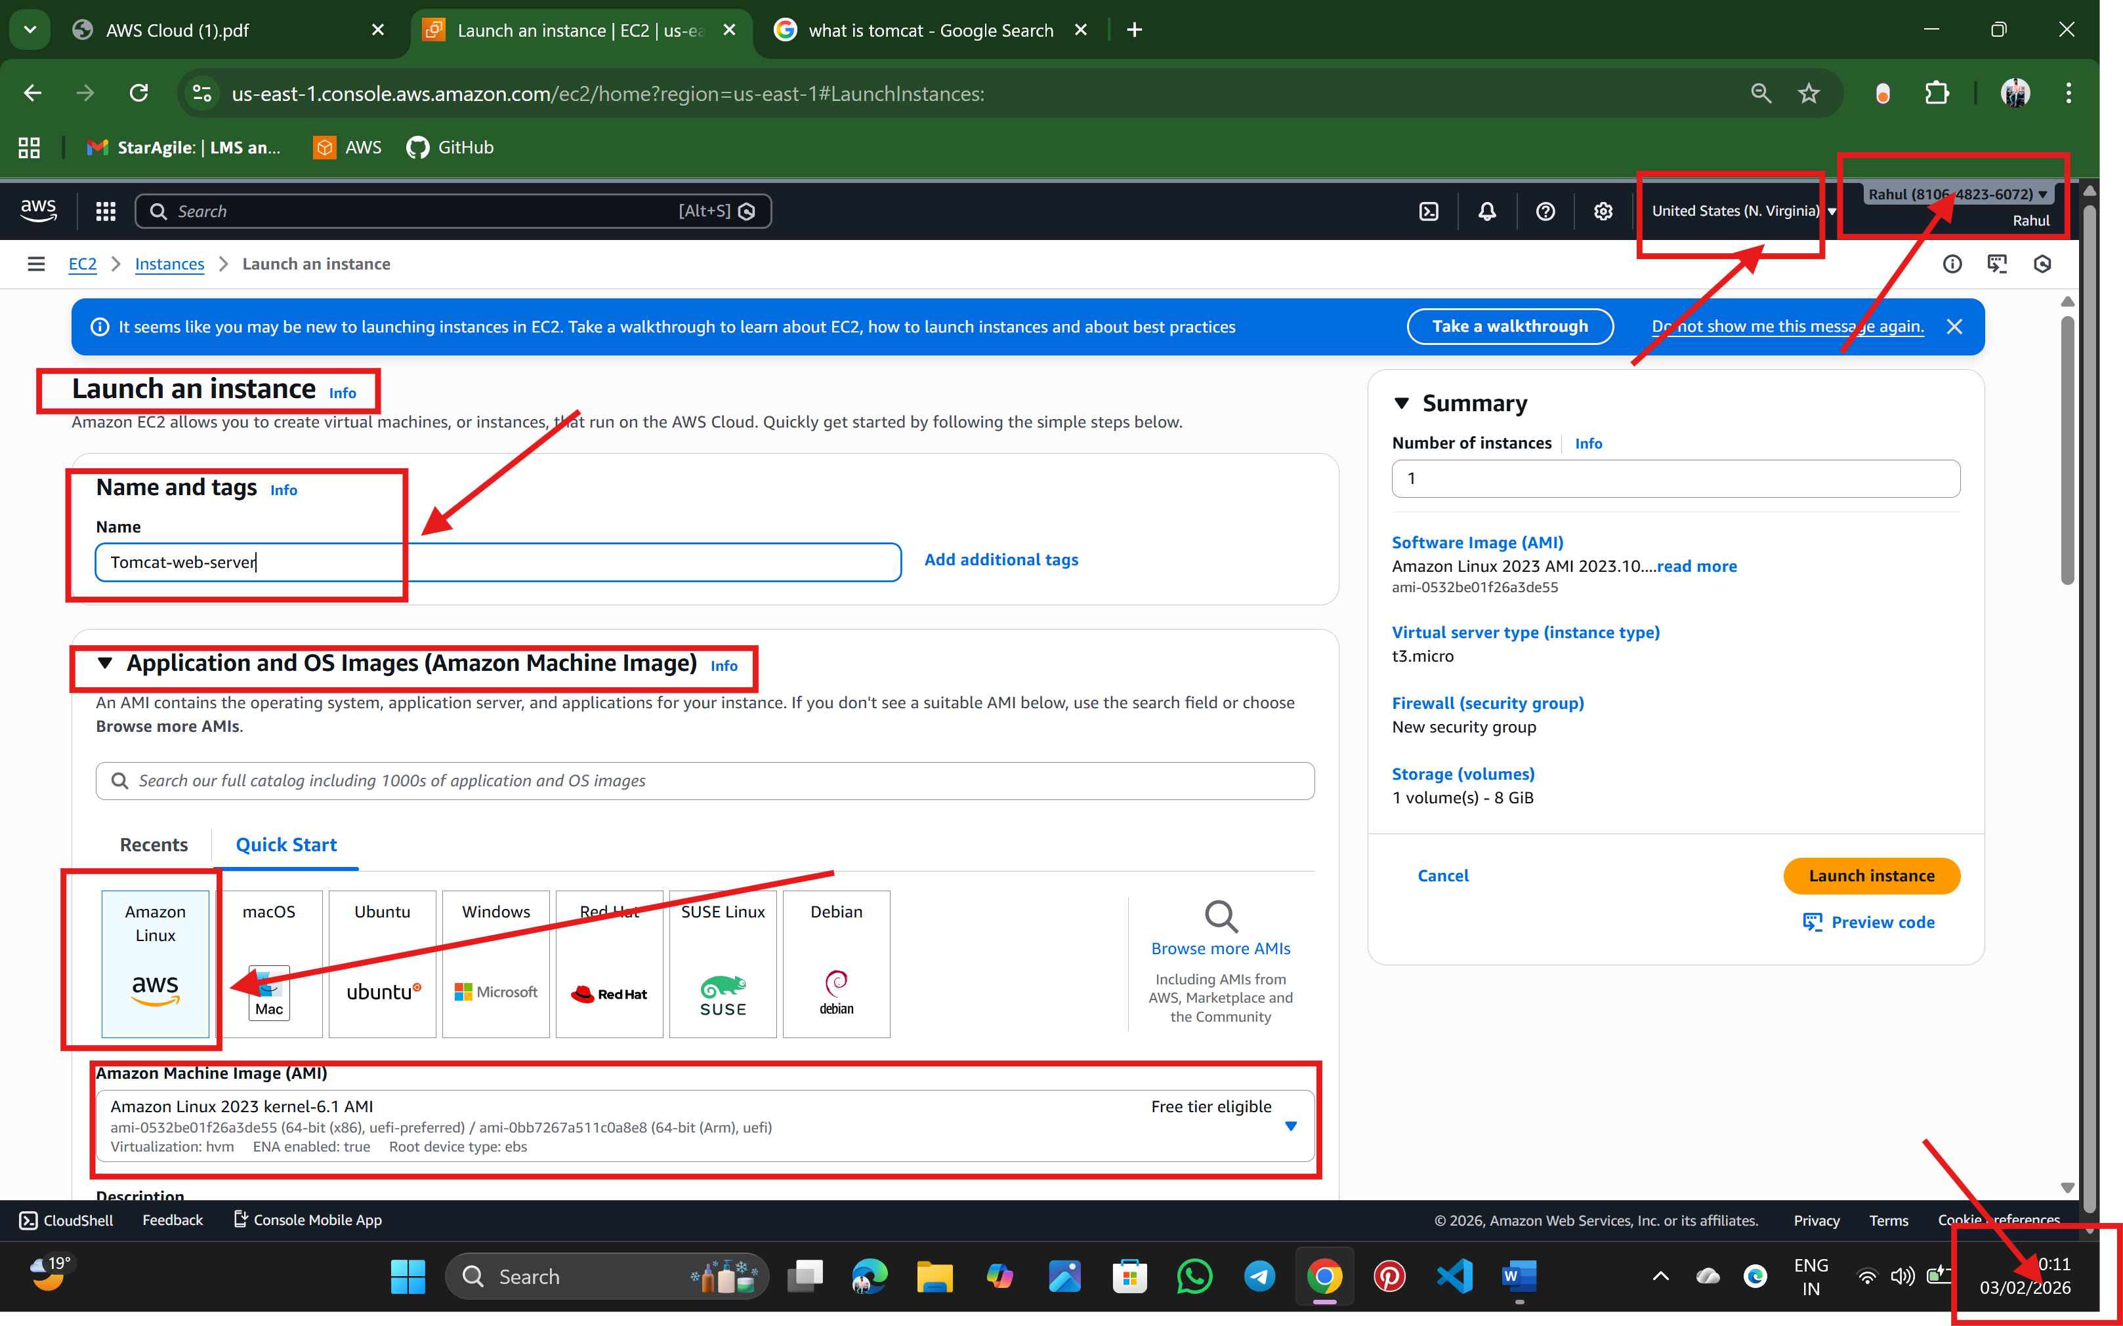

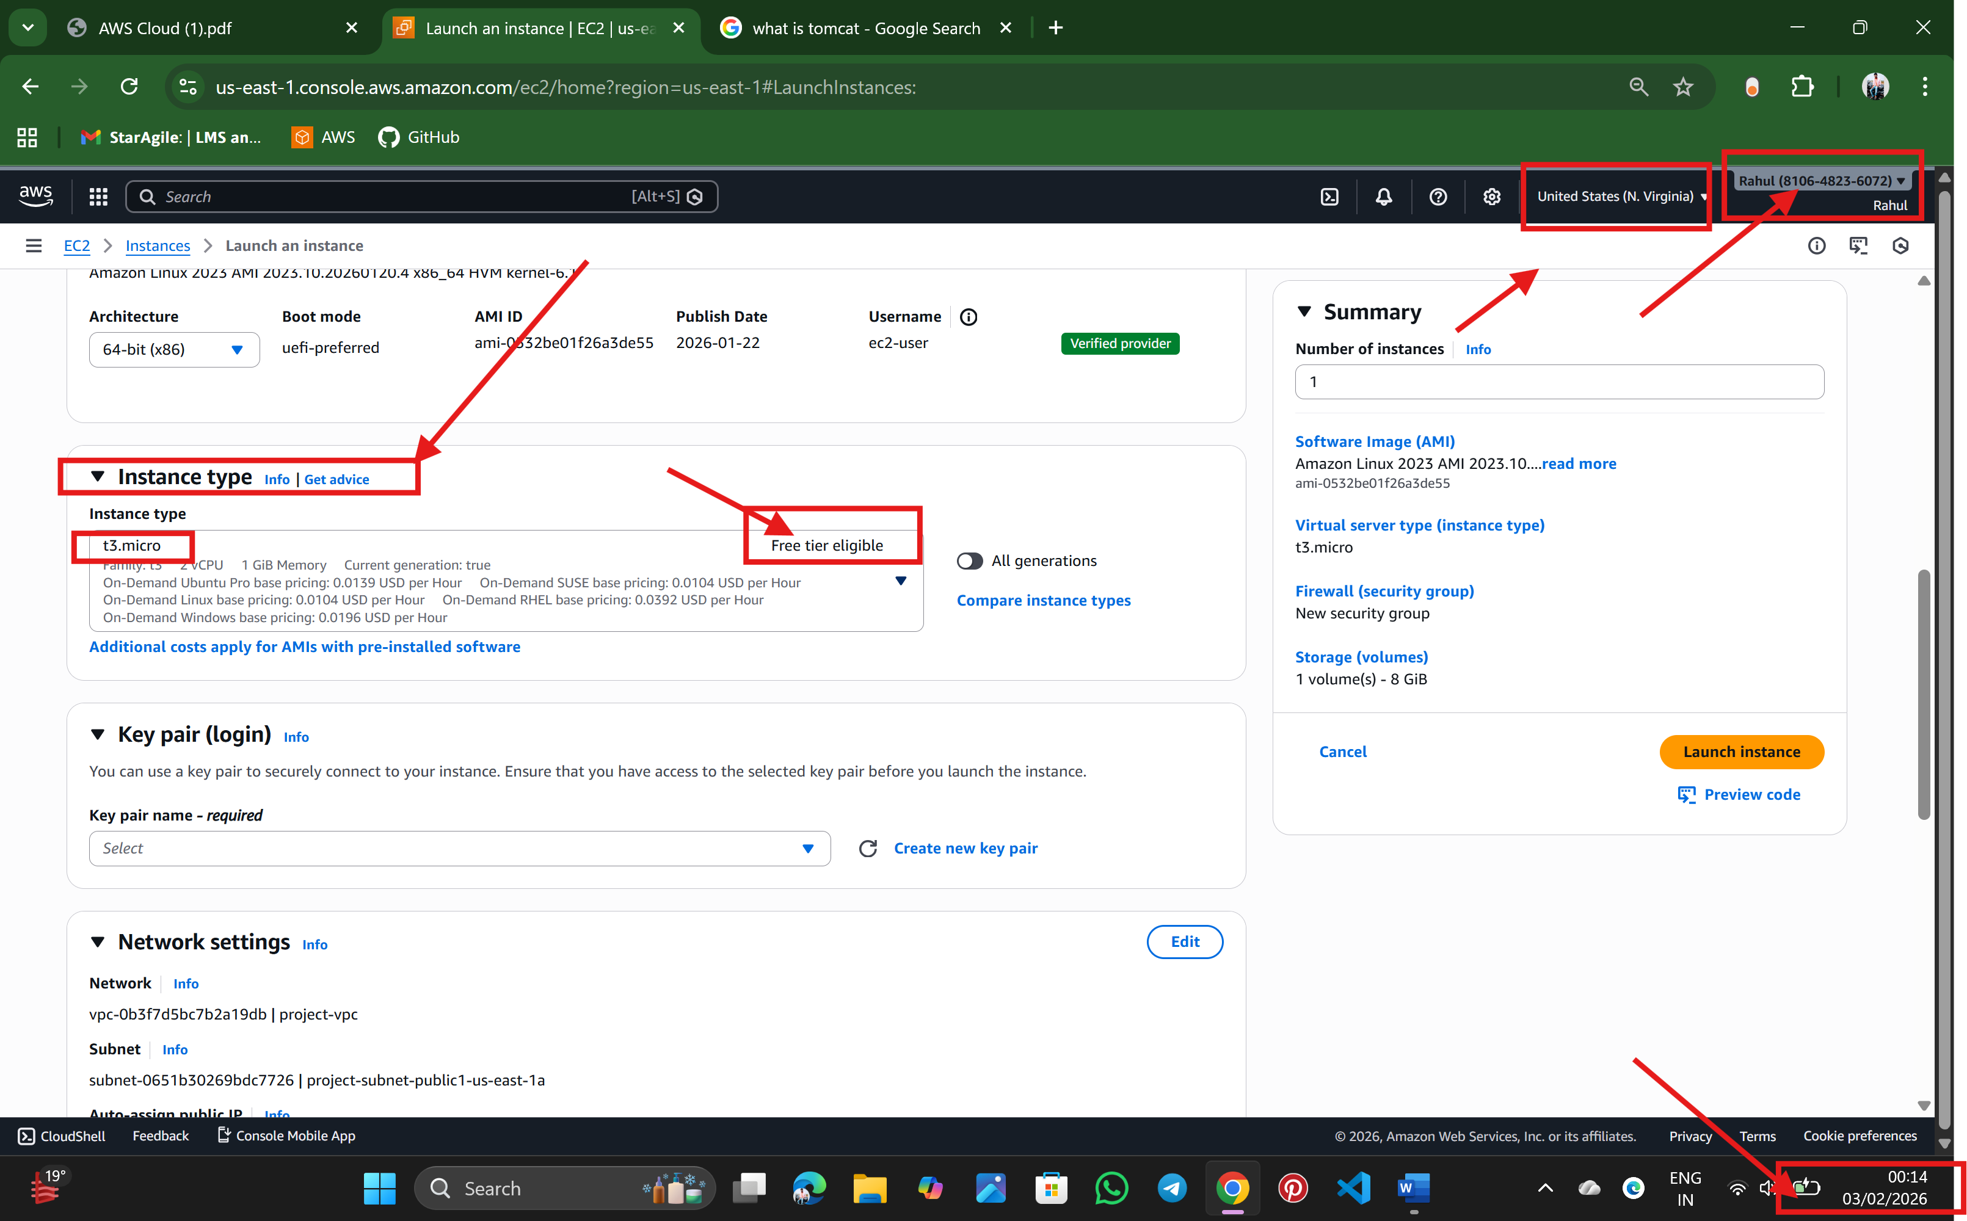

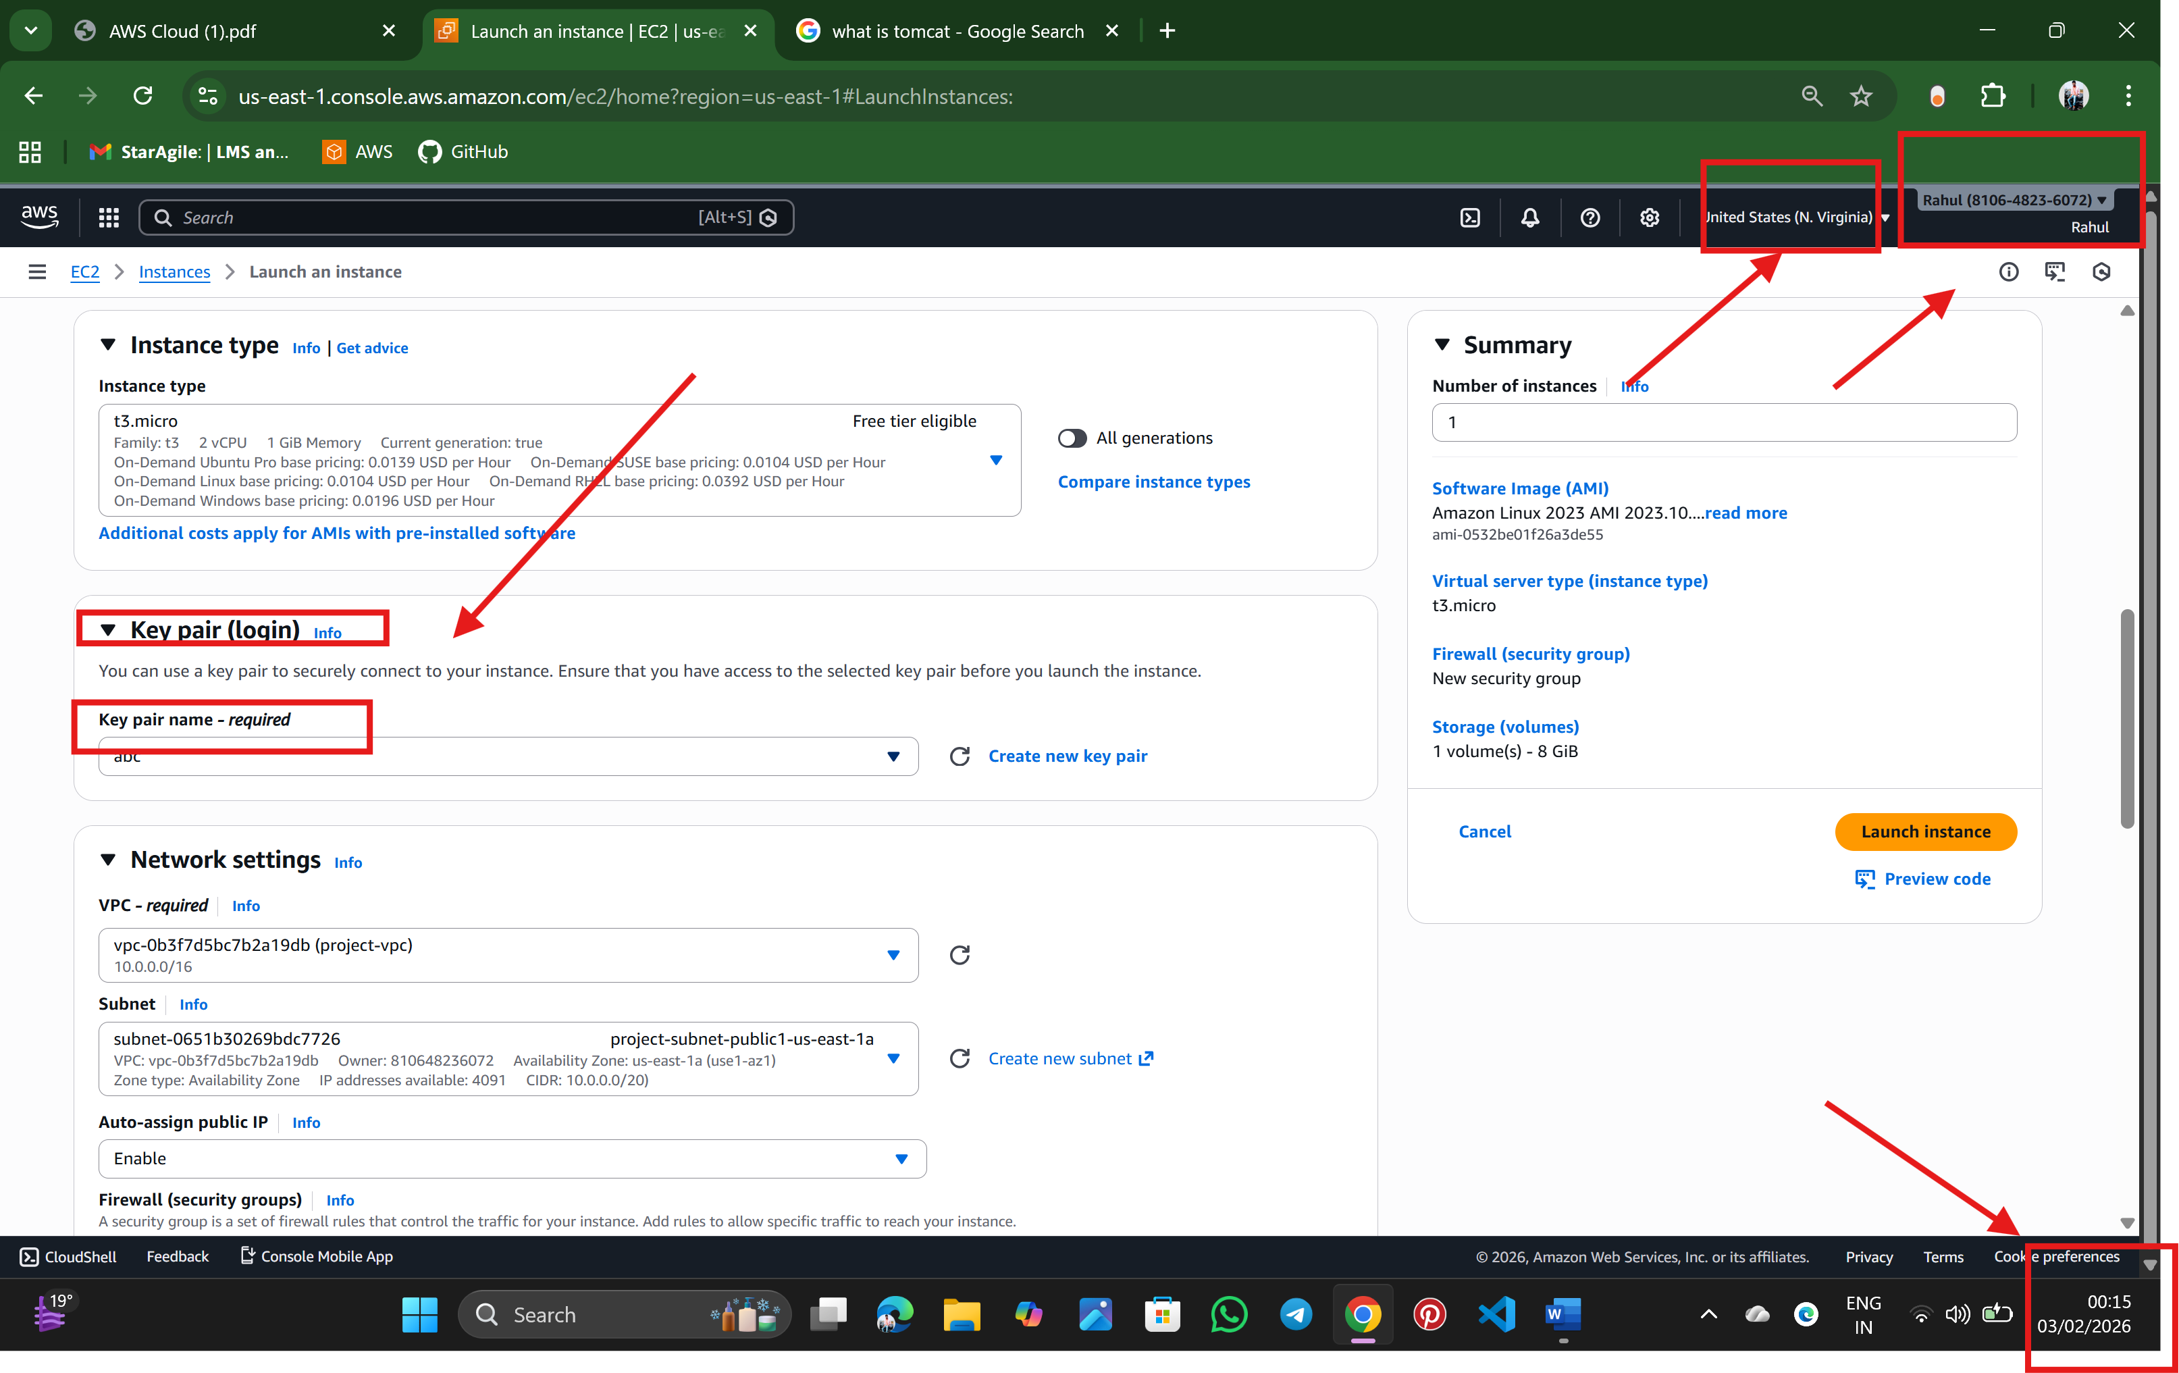

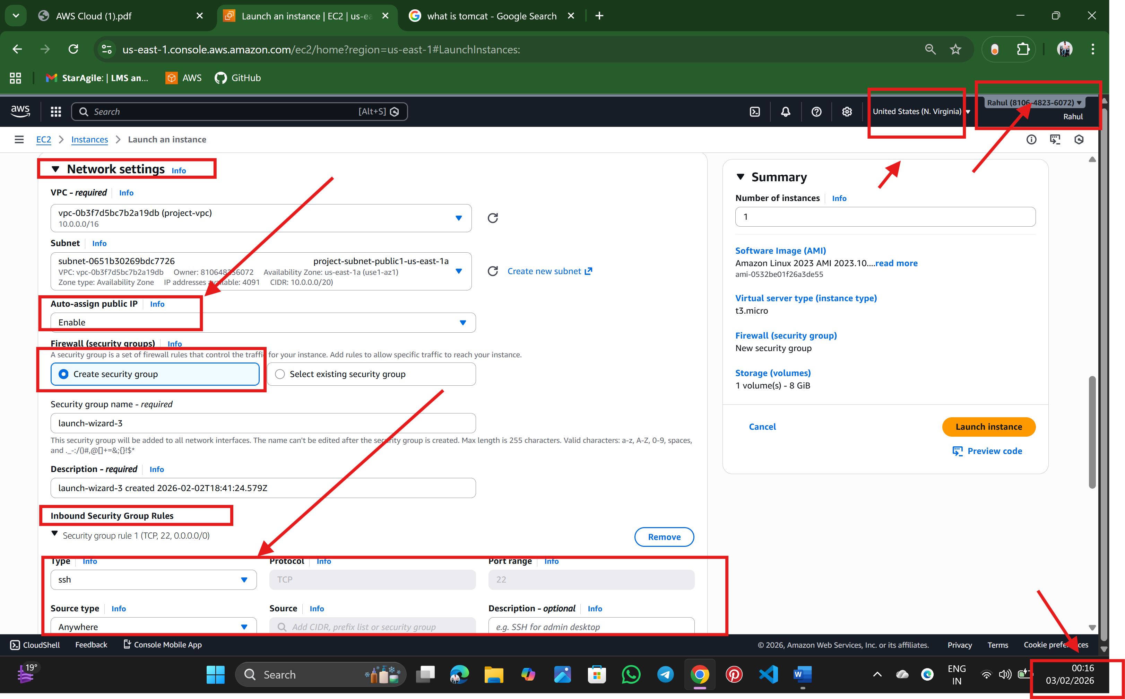

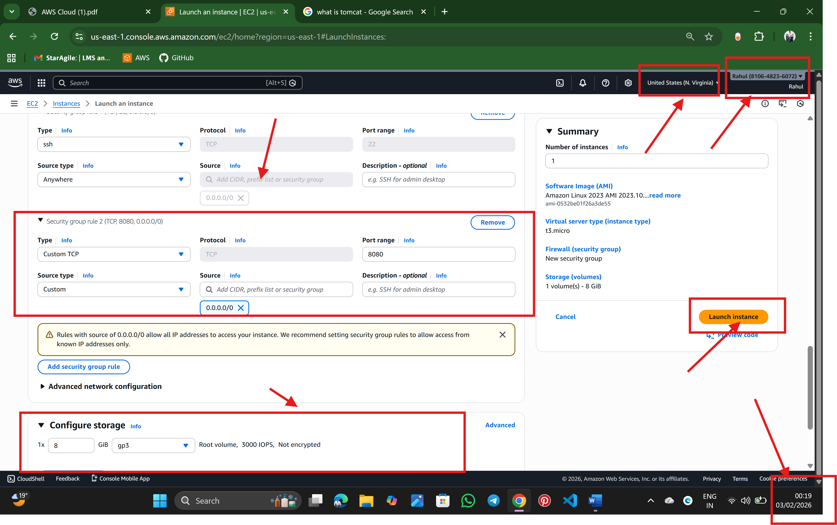

Step: 3 instance is launch successfully

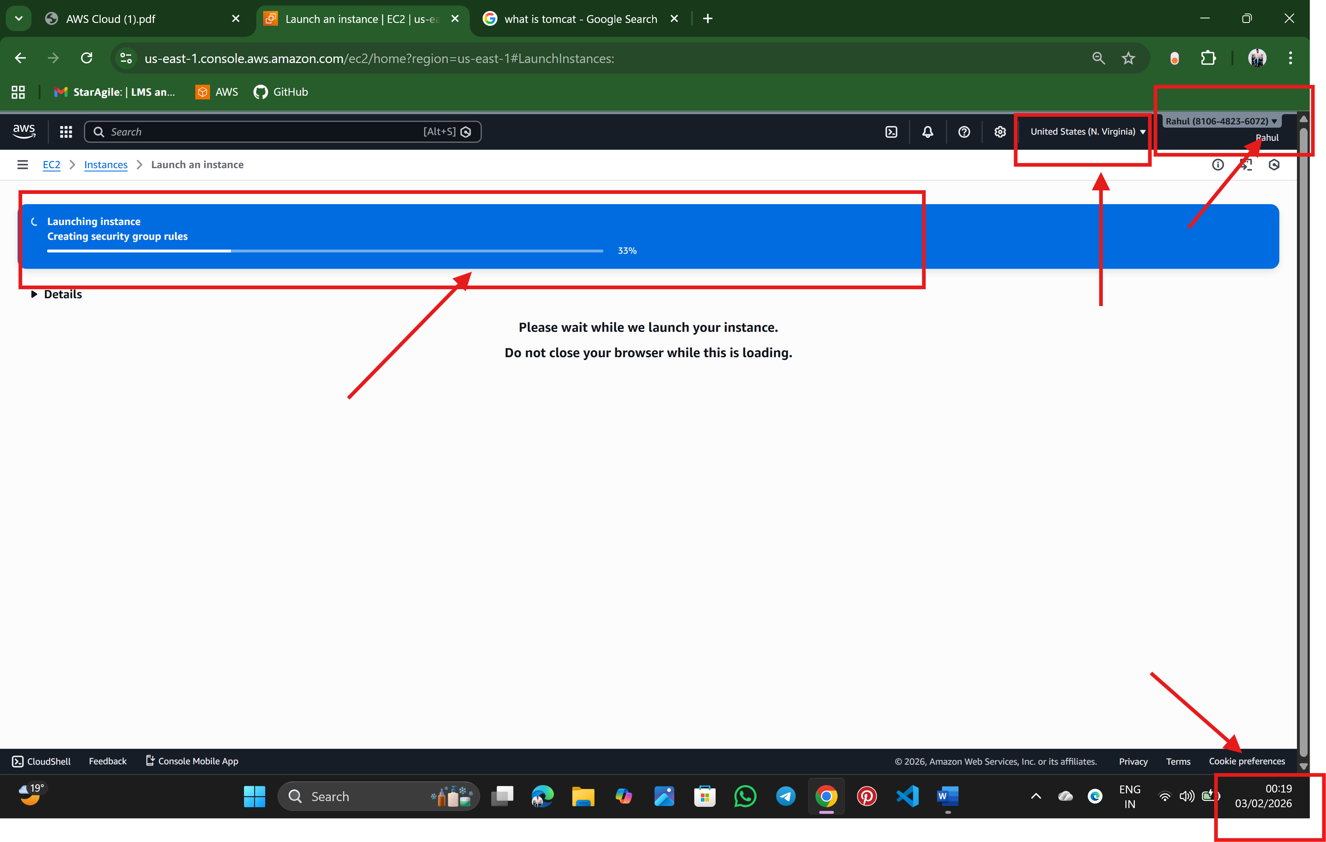

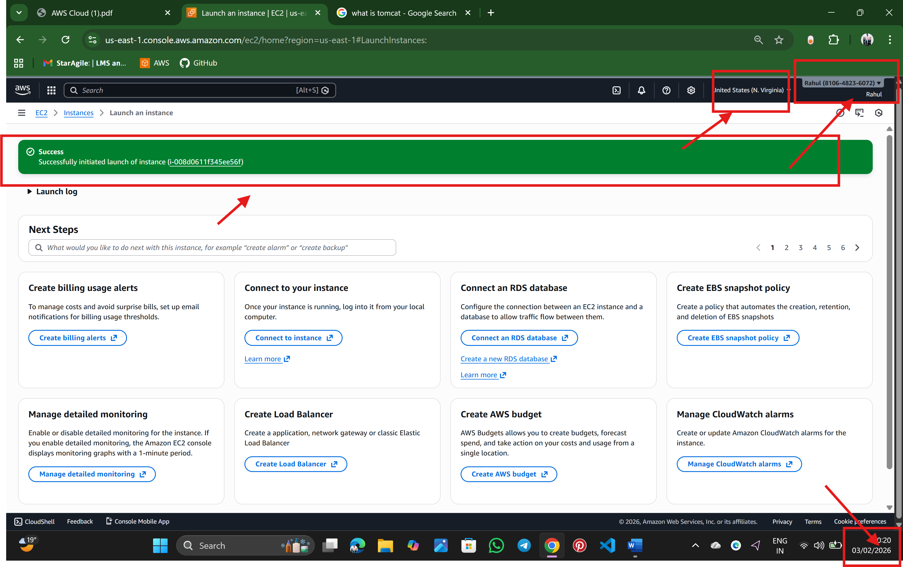

Step:4 connect the instance

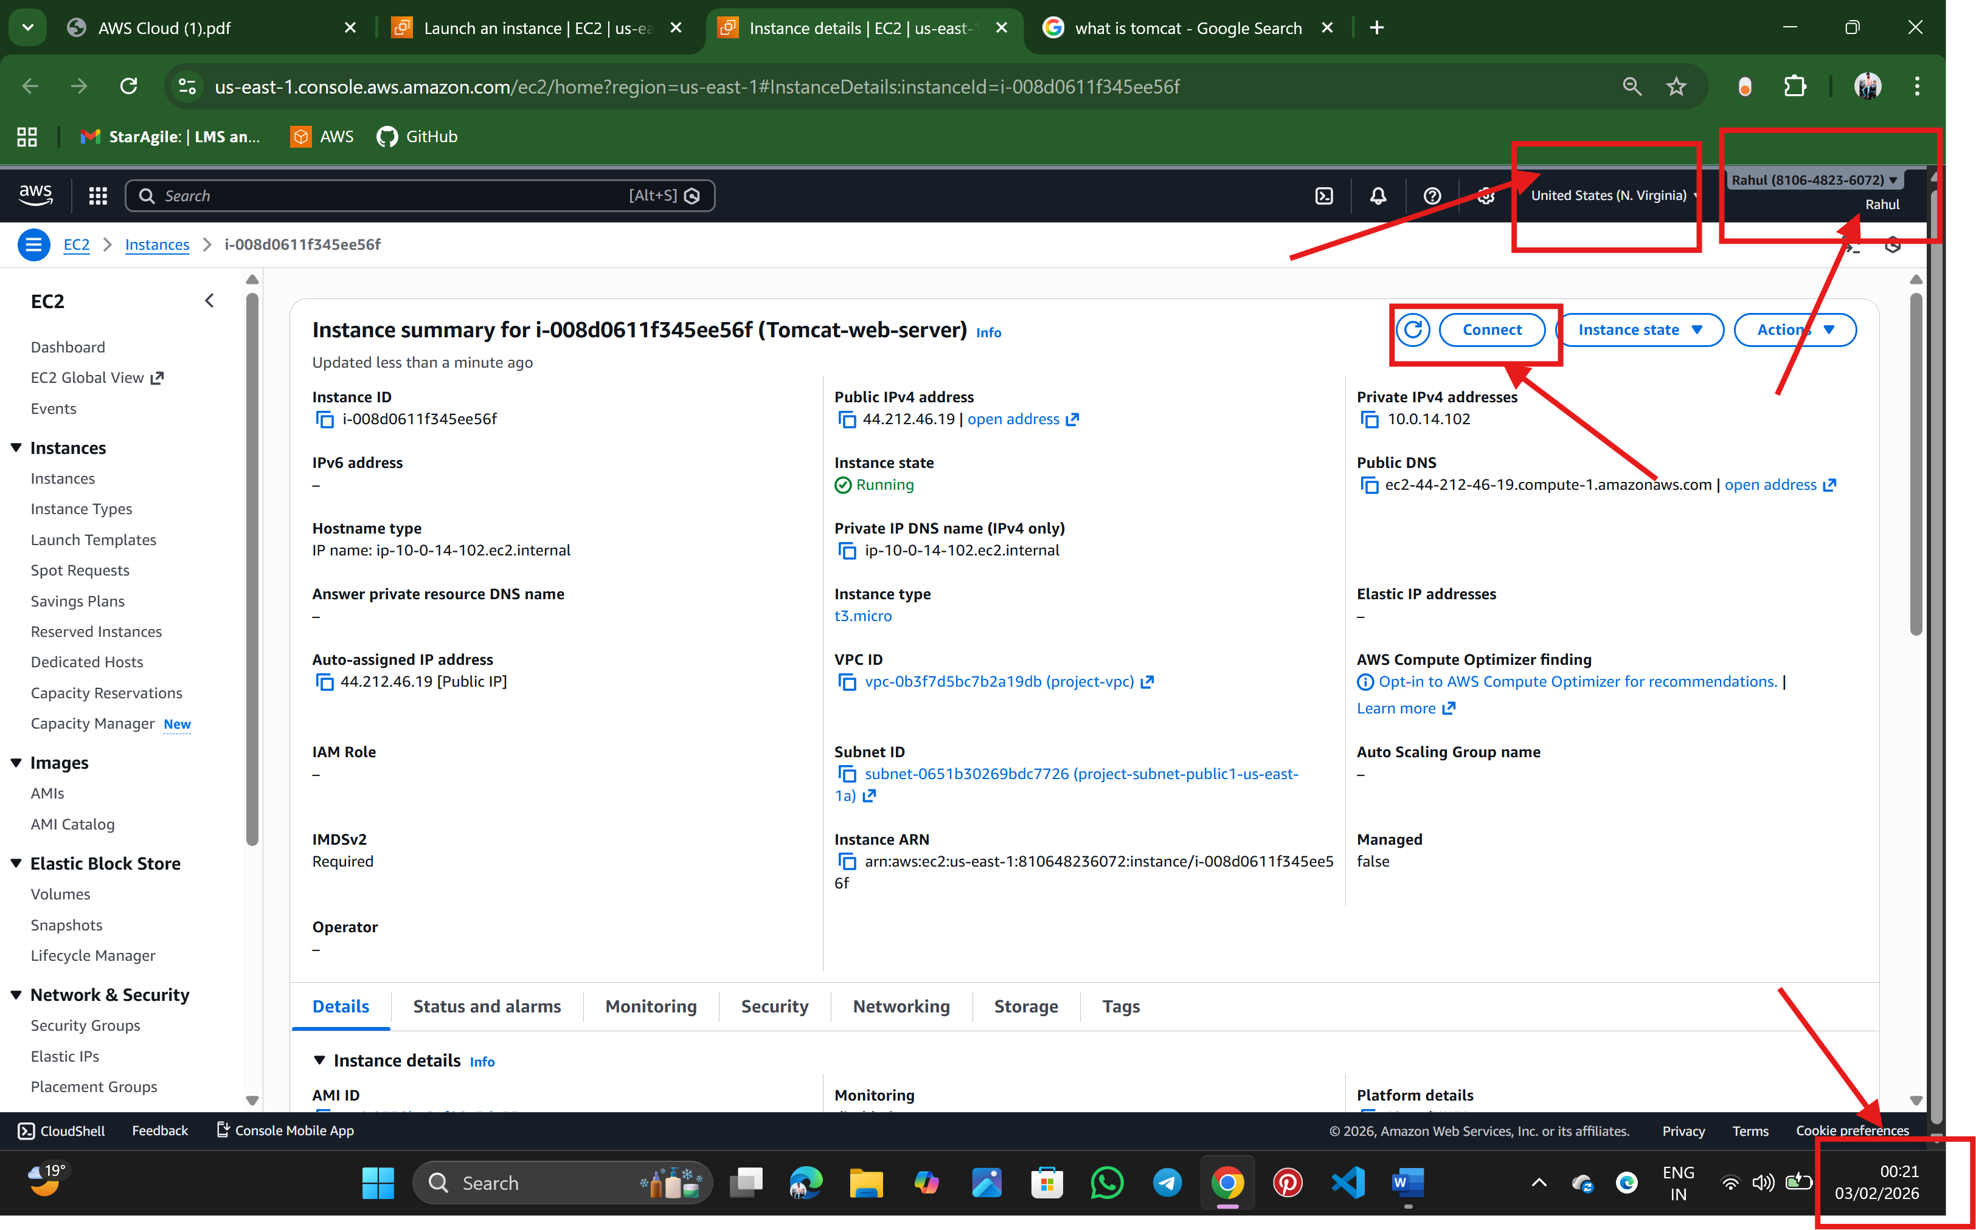

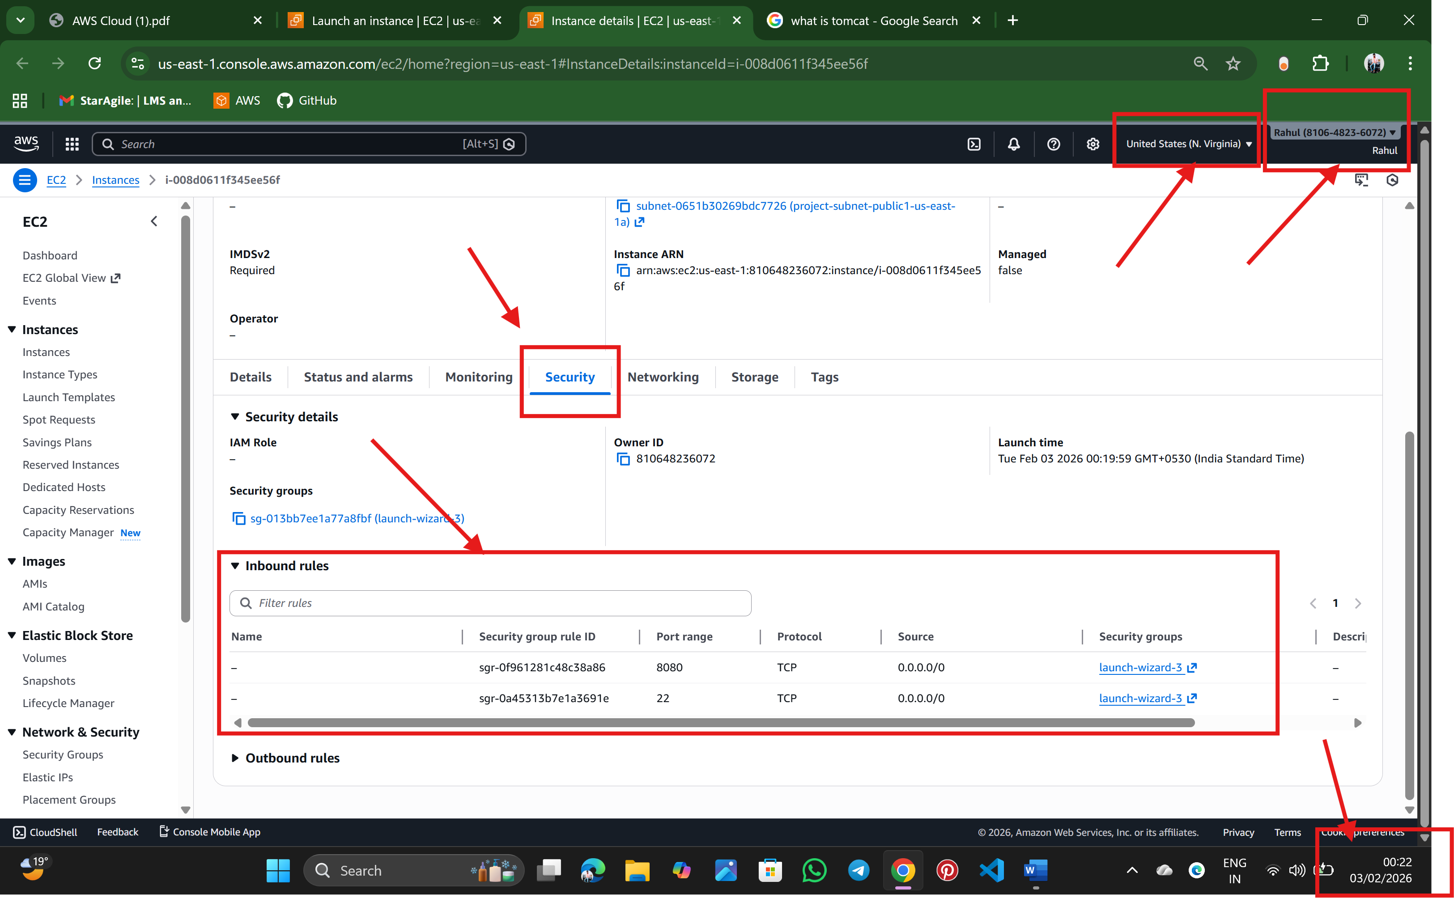 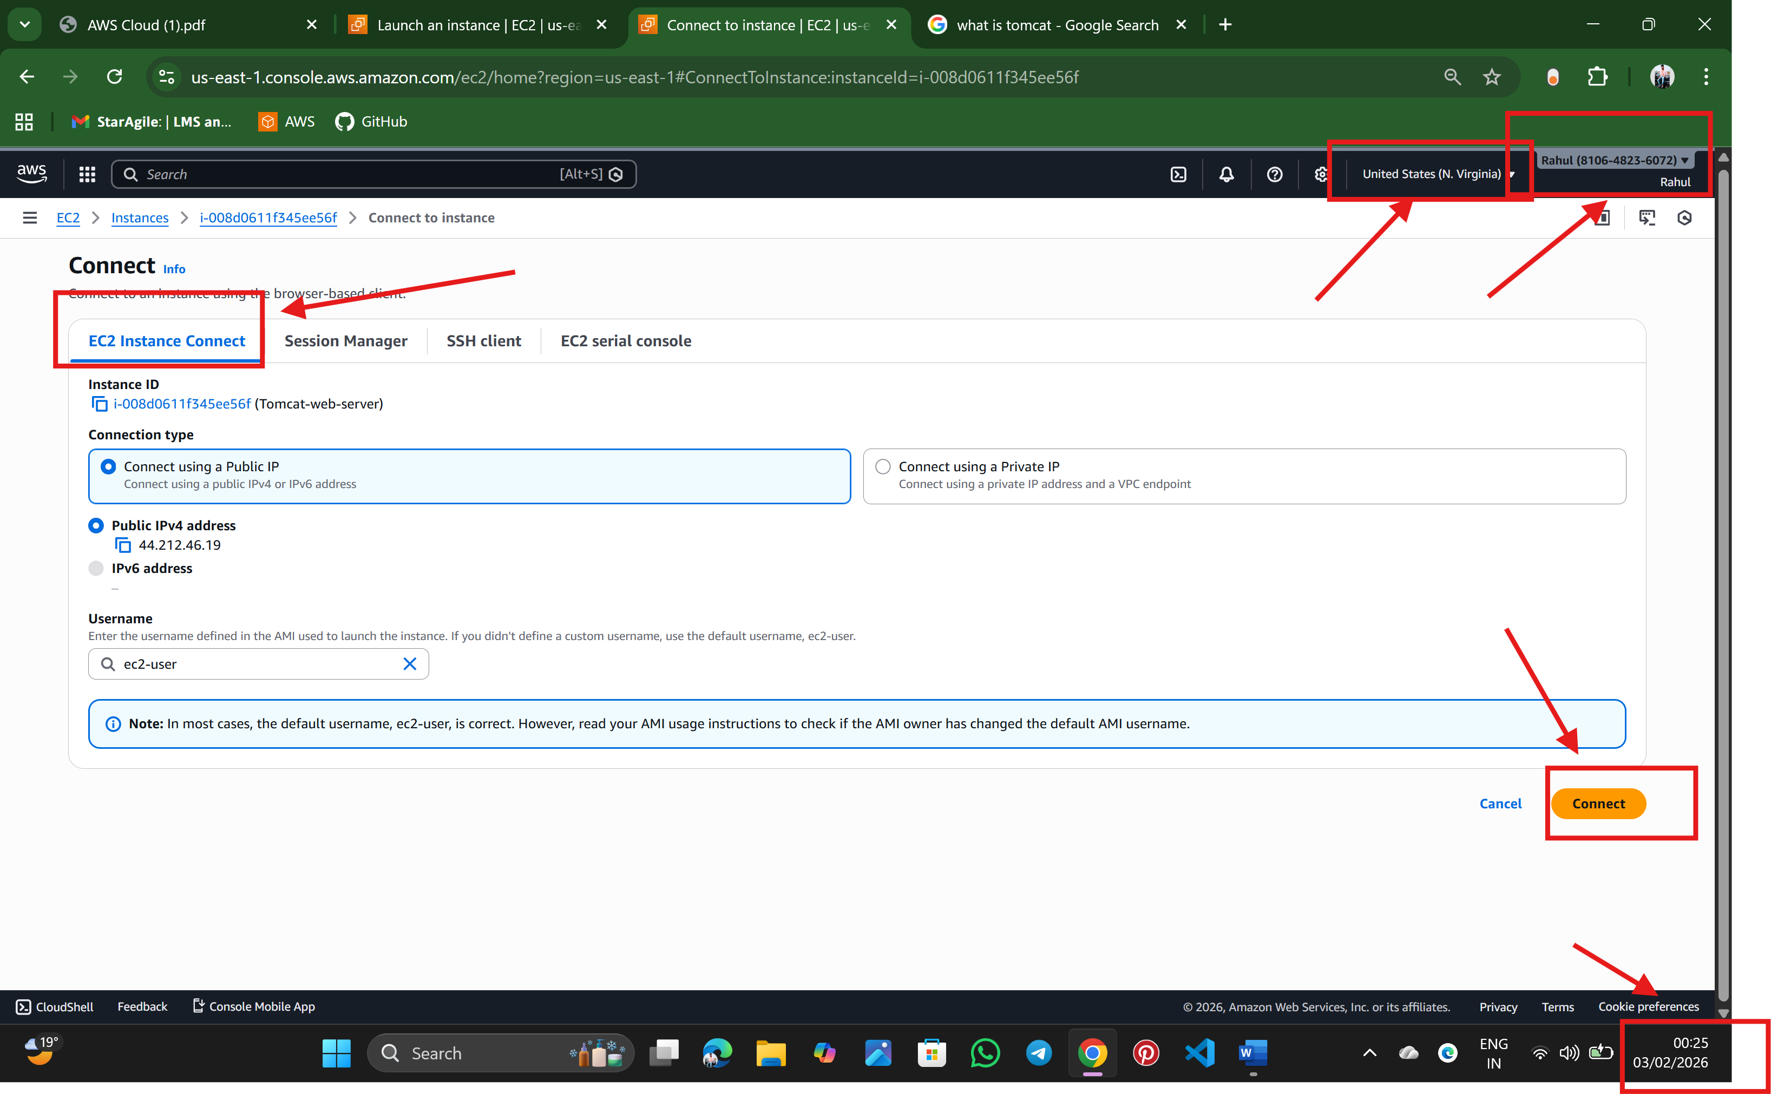

Step:5 Ubantu terminal is launched

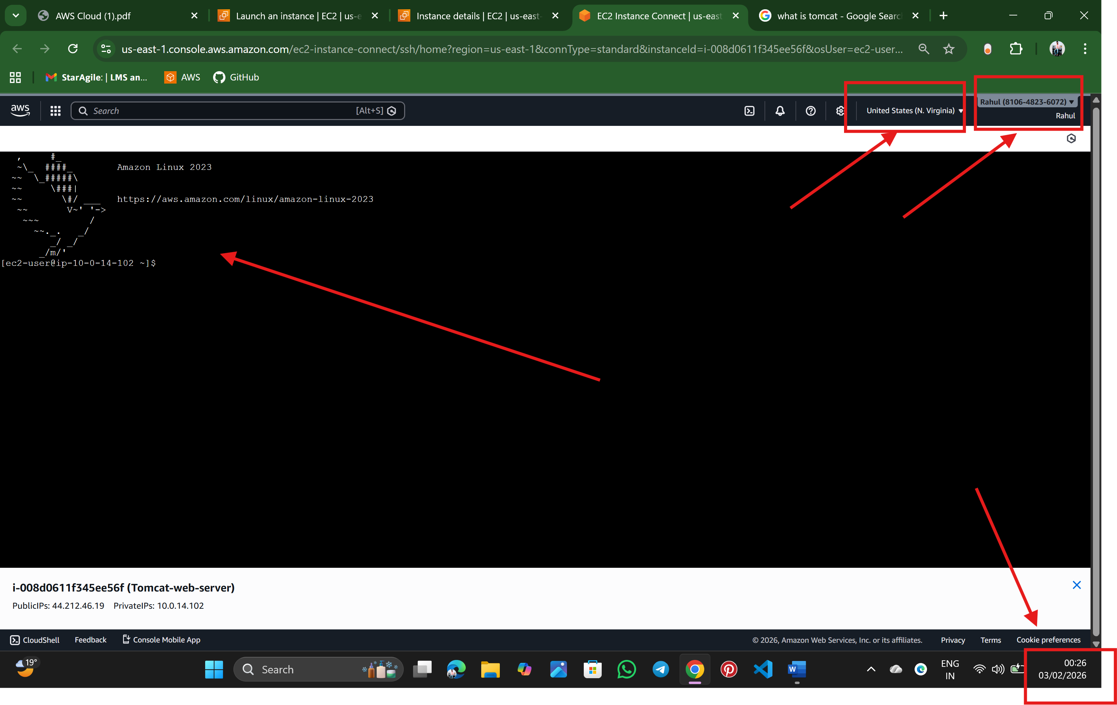

1. Tomcat 🡪an open-source web server used to deploy and run Java-based web applications.

2. why we use tom cat🡪used in various fields1. Web Application, 2. Hosting dynamic websites and applications

3. Getting some error so used stack overflow  
Reference🡪 <https://stackoverflow.com/questions/26637550/how-to-install-tomcat-in-amazon-web-> services-ec2

Step:6 Updated the default packages and installed the JDK  
  
Tomcat is an open server to un the java-based application  
switching to the root use for the full access

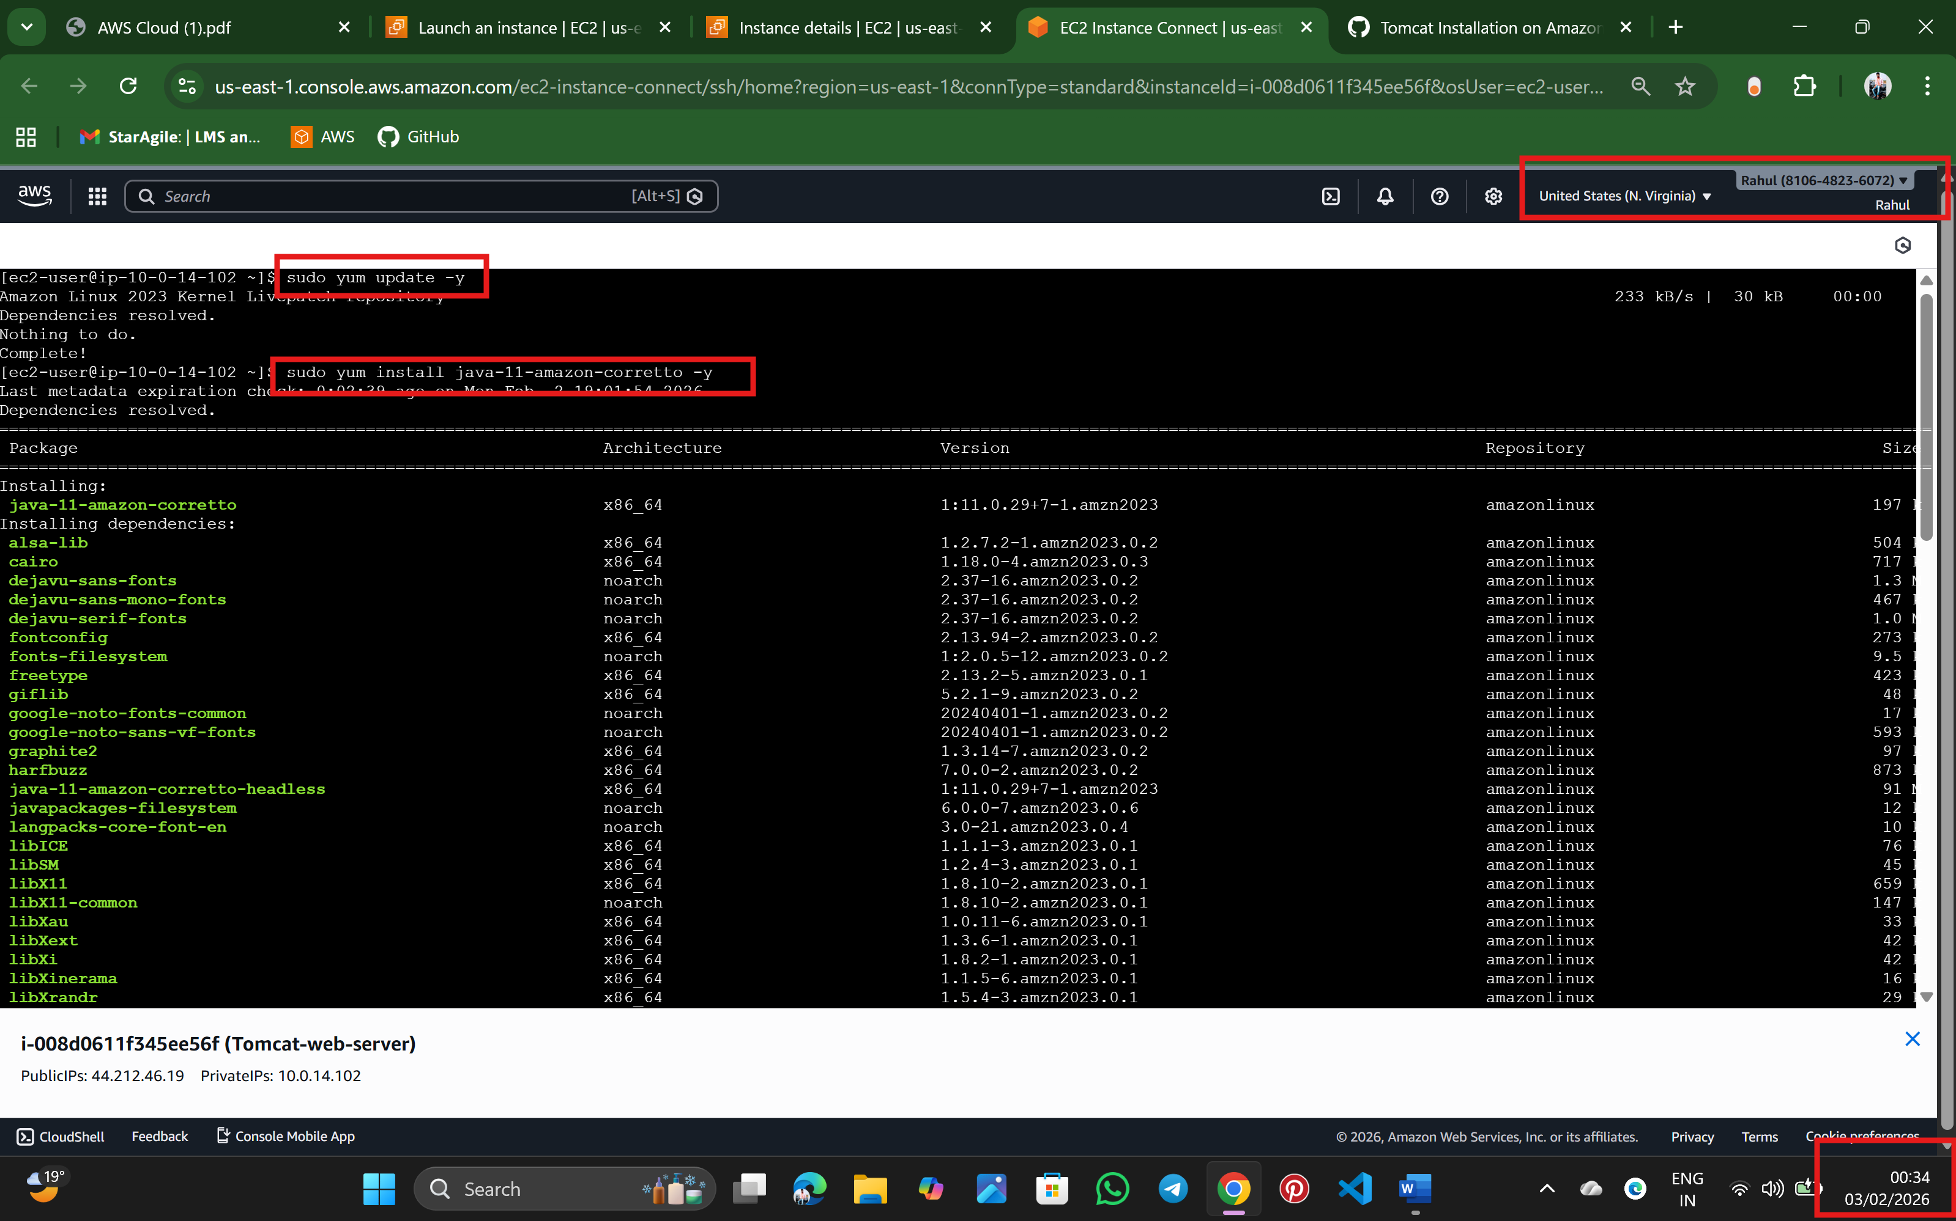

Step:7 Verify the java version using java --version  
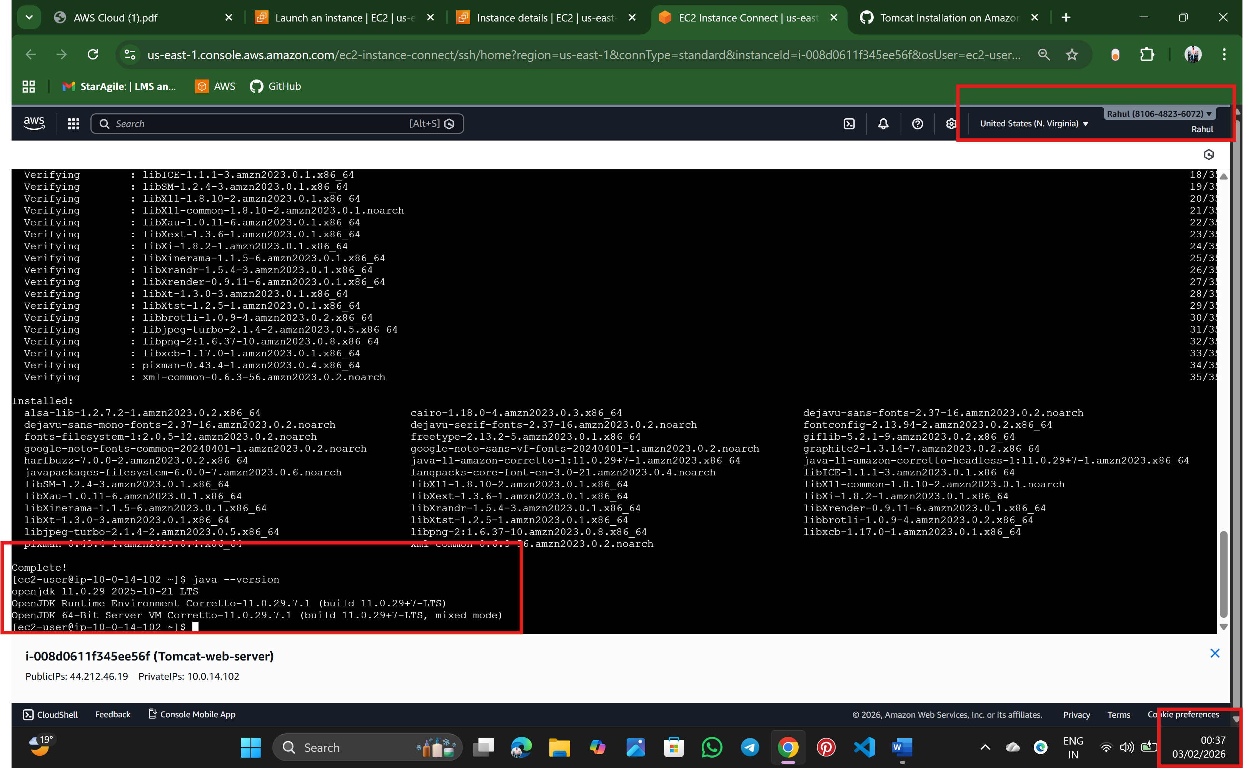

Step: 8 /opt is used for **optional / third-party software**

Tomcat is **not a system tool**, so /opt is correct place  
Downloading the tomcat version 10 (Downloads **Apache Tomcat software** from the internet)  
  
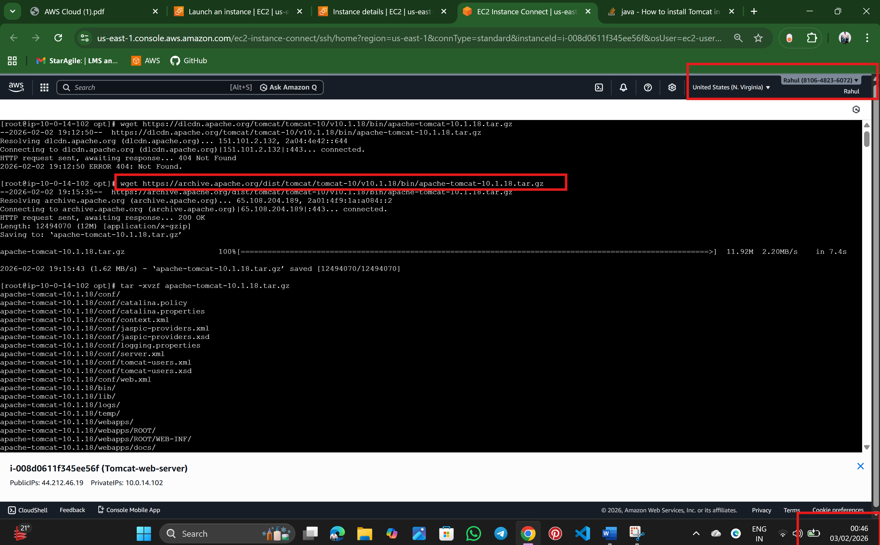

Step: 9 Extract the tomcat files  
tar -xvzf apache-tomcat-10.1.18.tar.gz  
-x 🡪 extract  
v 🡪 show all the files while extracting  
z🡪 zip formmate  
f🡪file name  
  
  
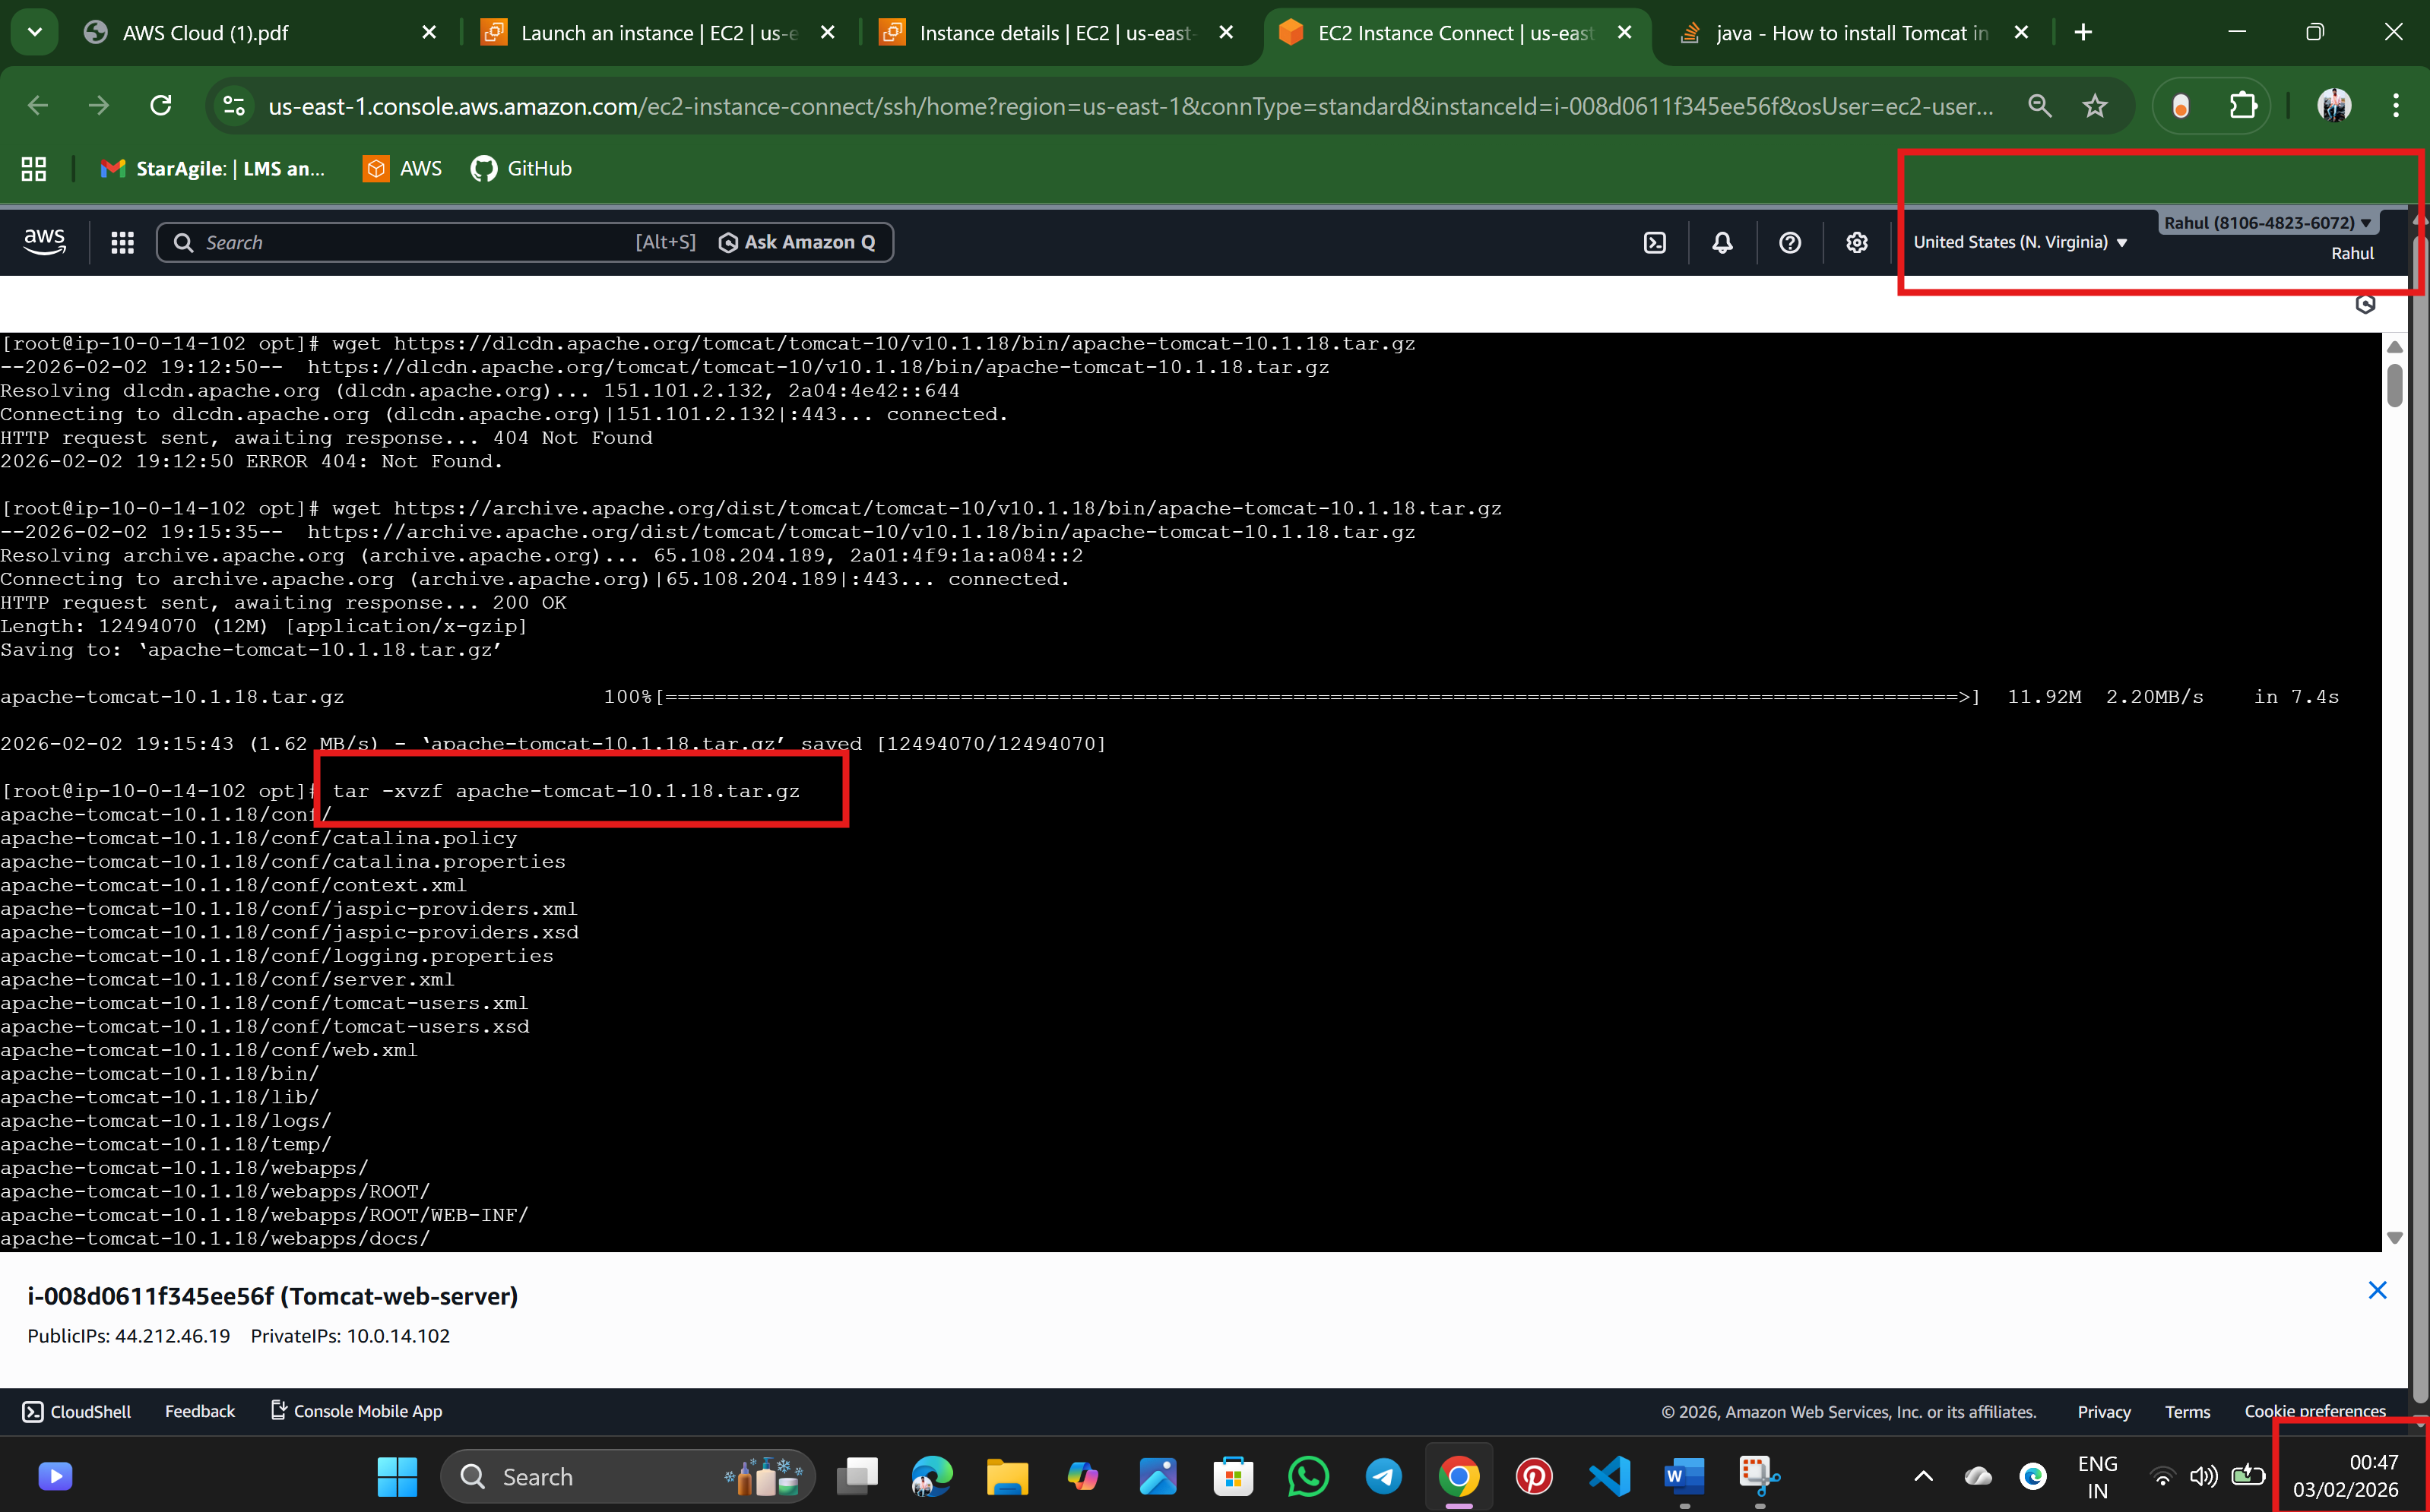  
  
Step:9 Verify the extract file and rename the tomcat file for easy reference  
  
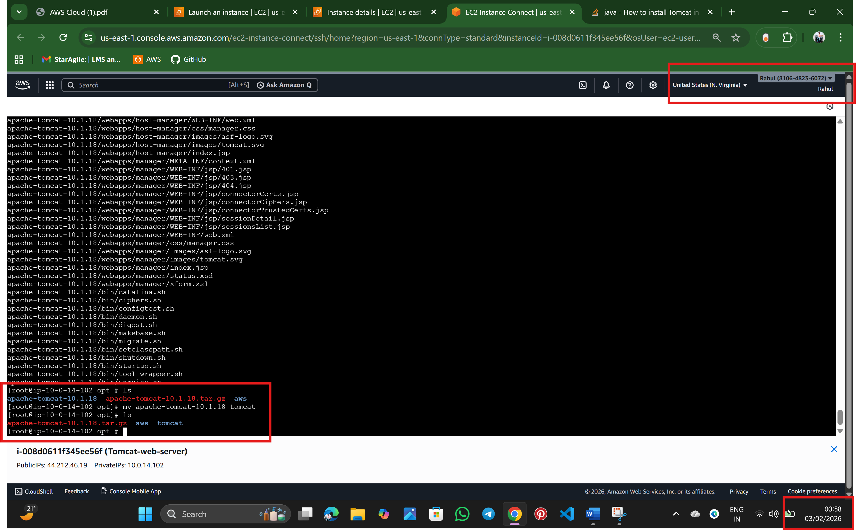

Step:10 Need to locate the .sh files to execute, there are so many .sh file so we are using * to give all .sh files to excure   
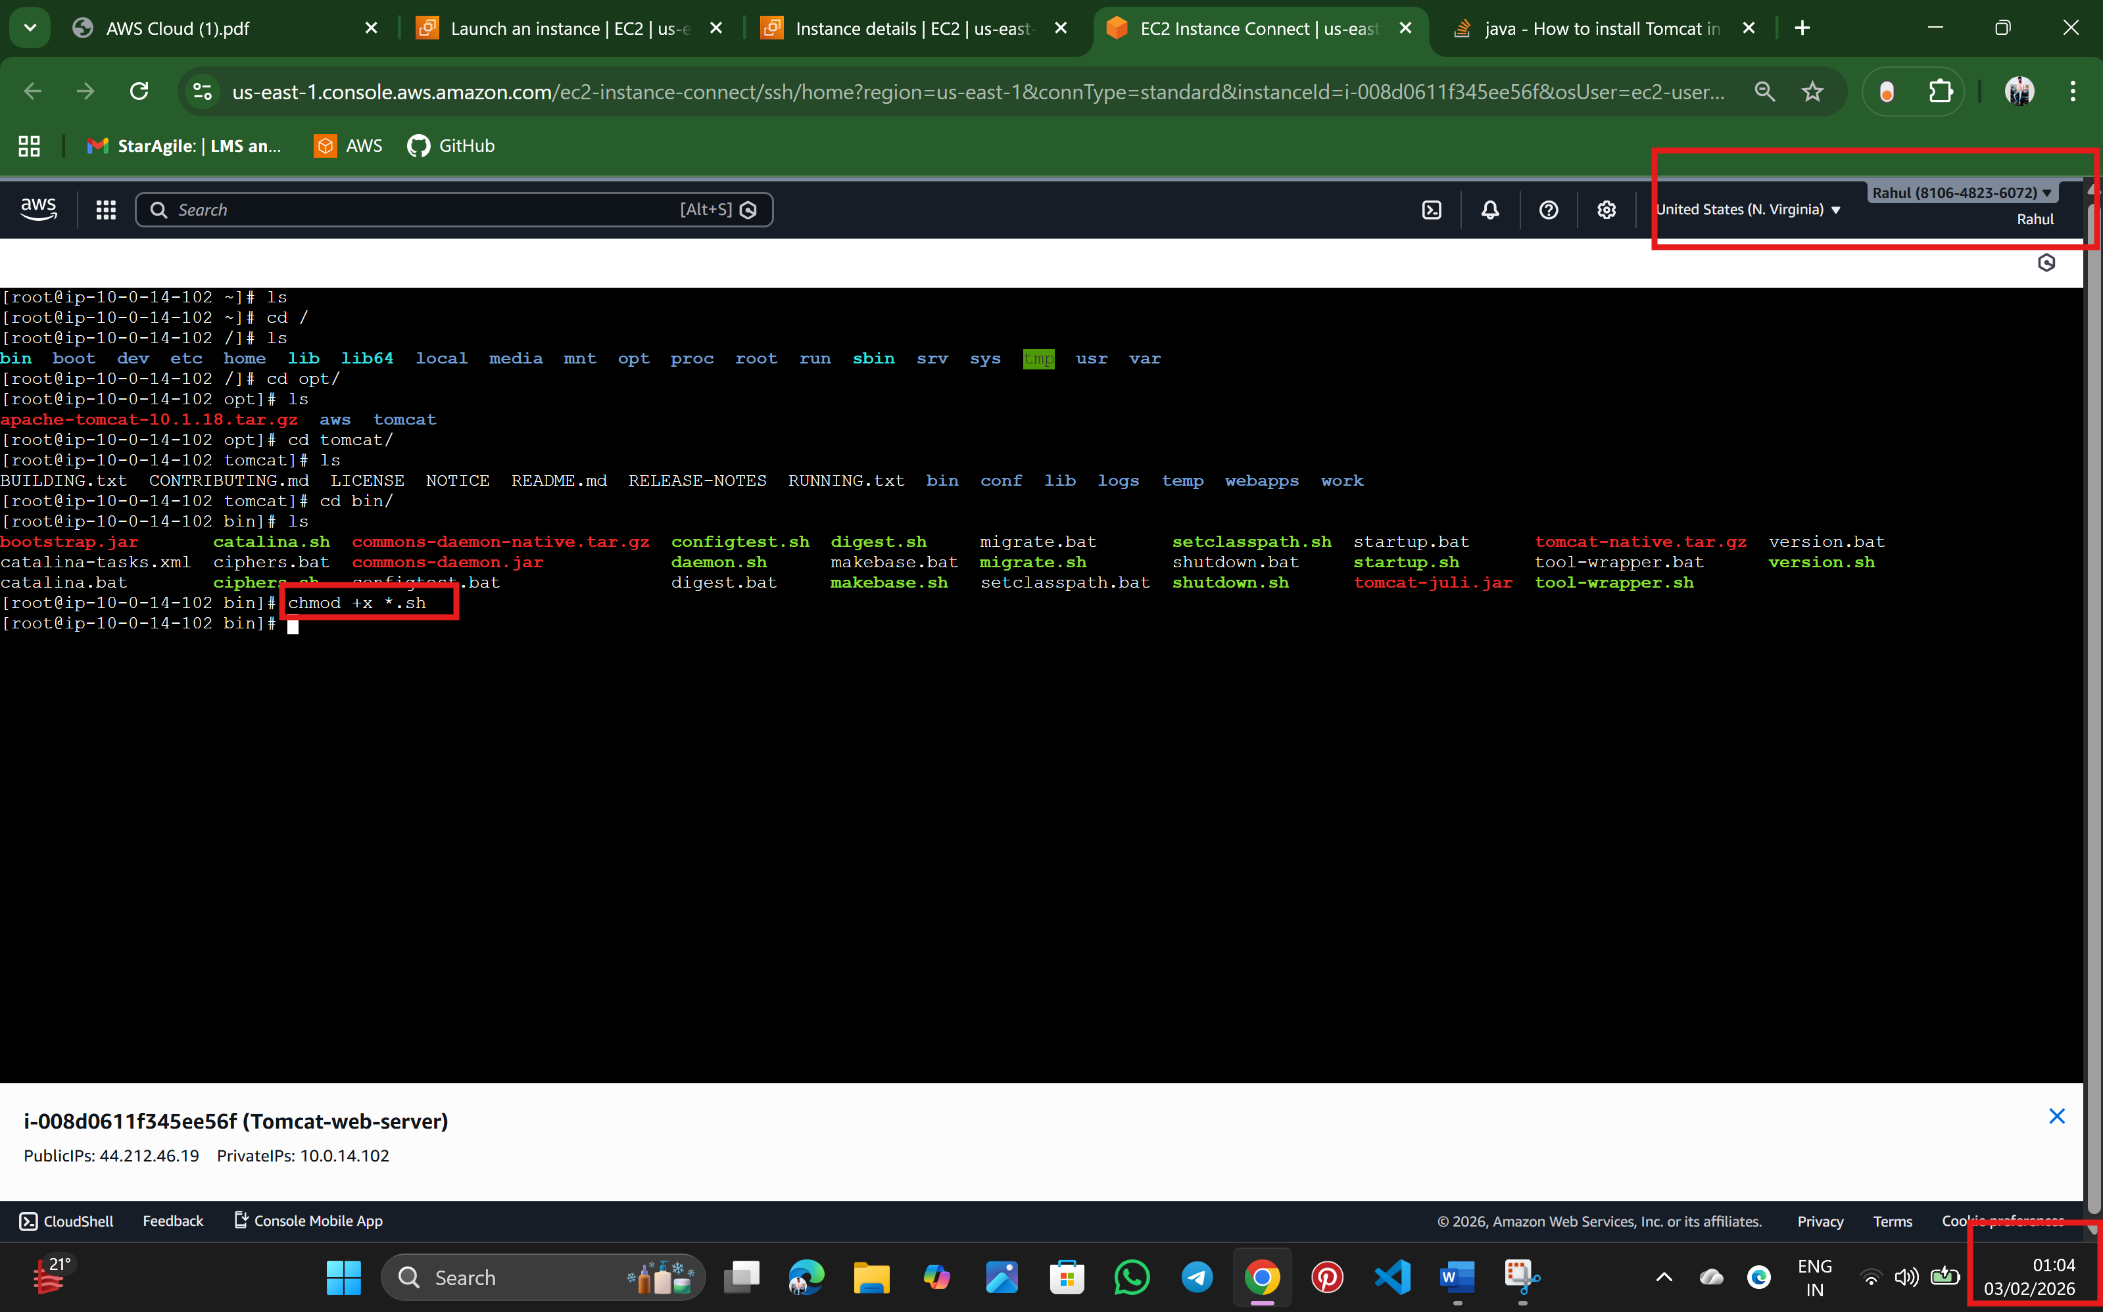  
  
Step:11 Start Tomcat Server  
  
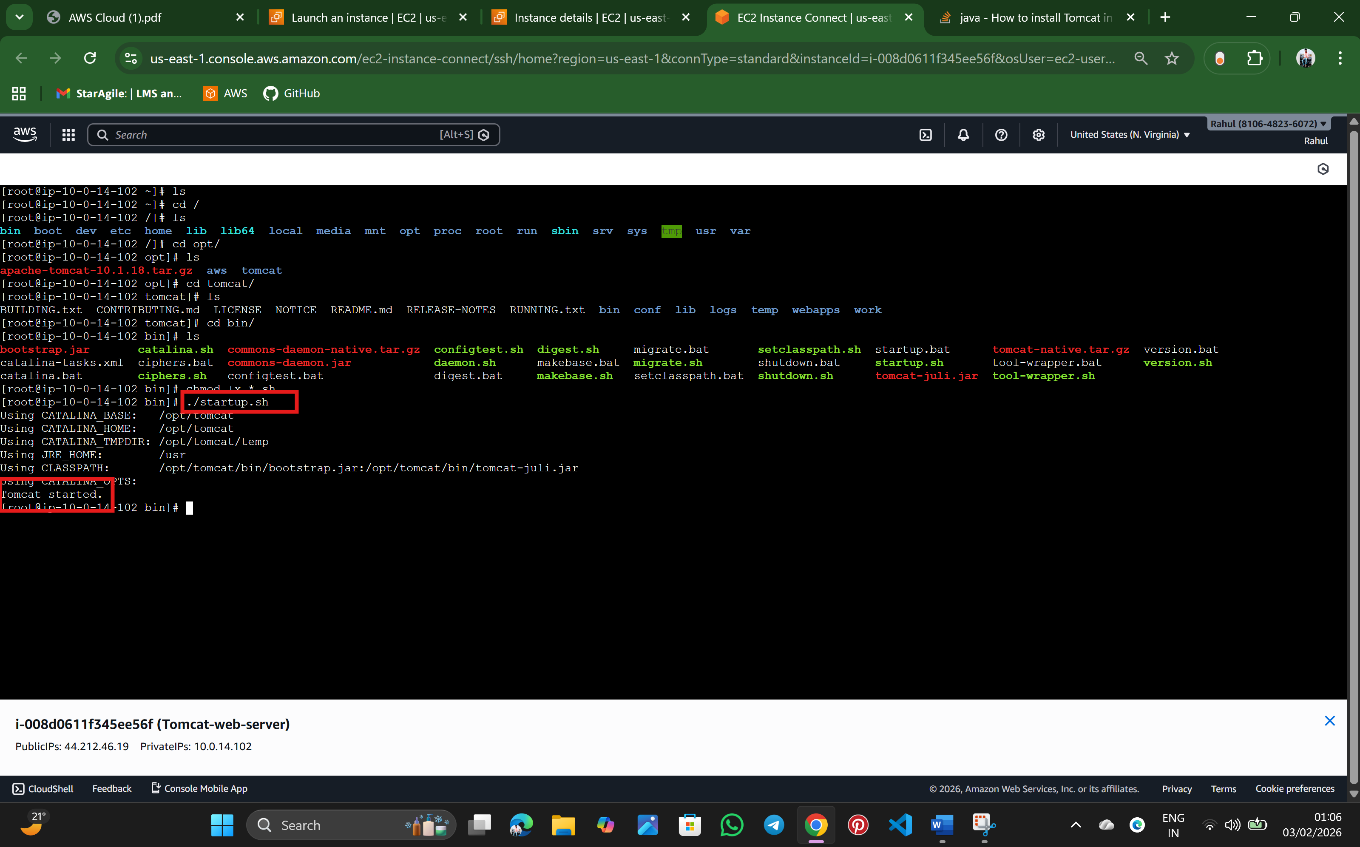

Step:12 finally, it working   
  
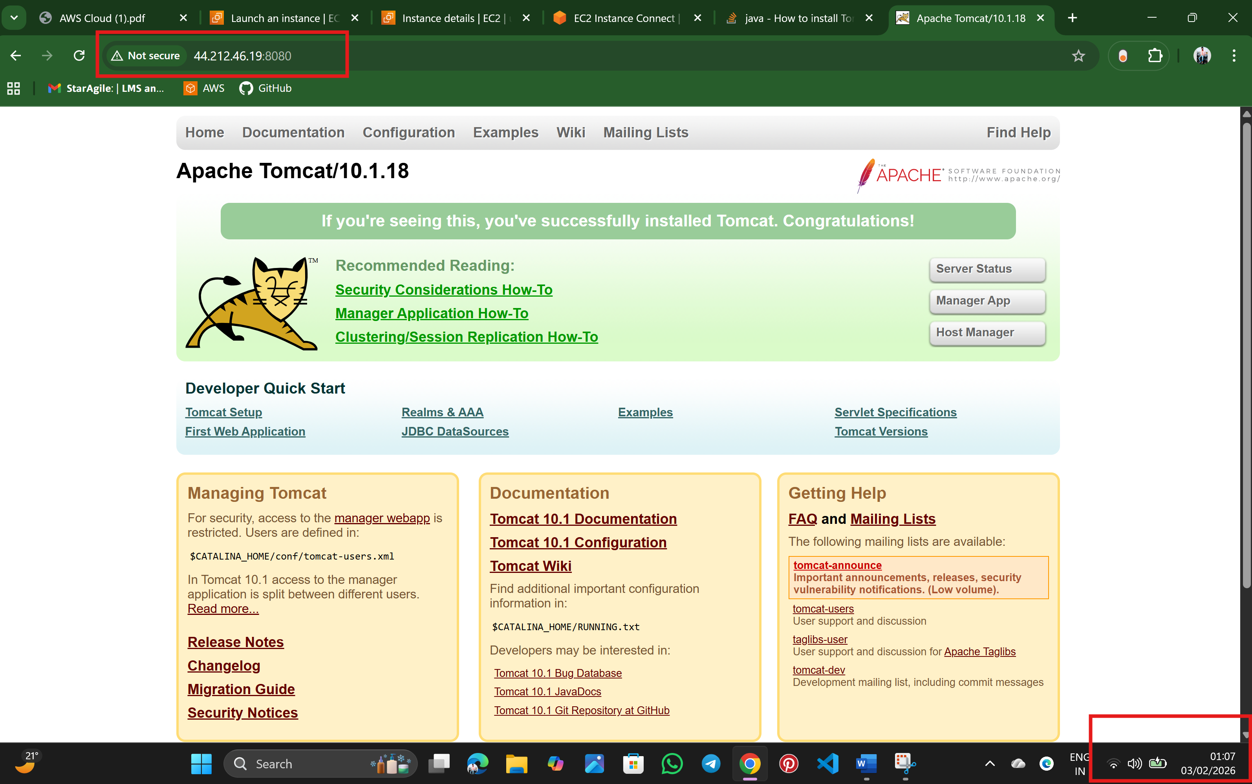

* Rahul Nalathati